Demo Video as per Guidelines
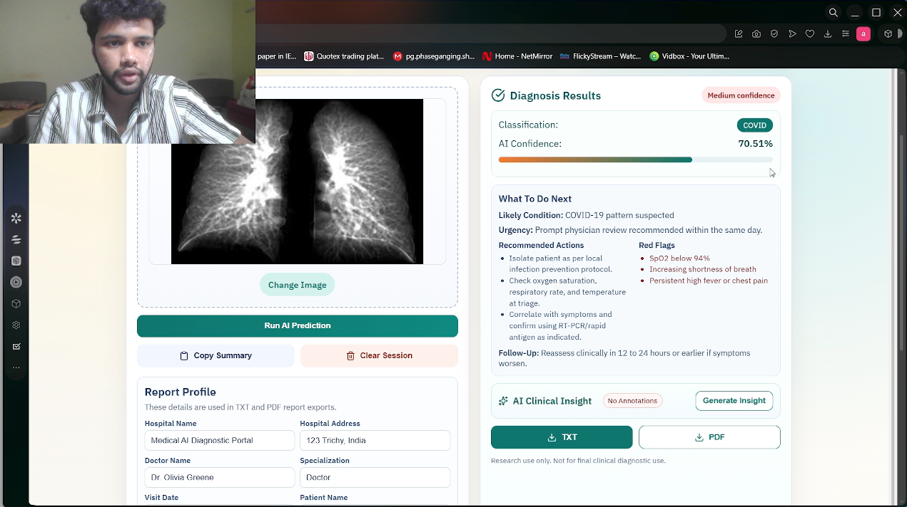

Fig 66 : Vidio Drive Link : https://drive.google.com/drive/folders/1HYollCRsFegY67pfavab6J0K13X4rnKf?usp=sharing

Github Repo and Fork
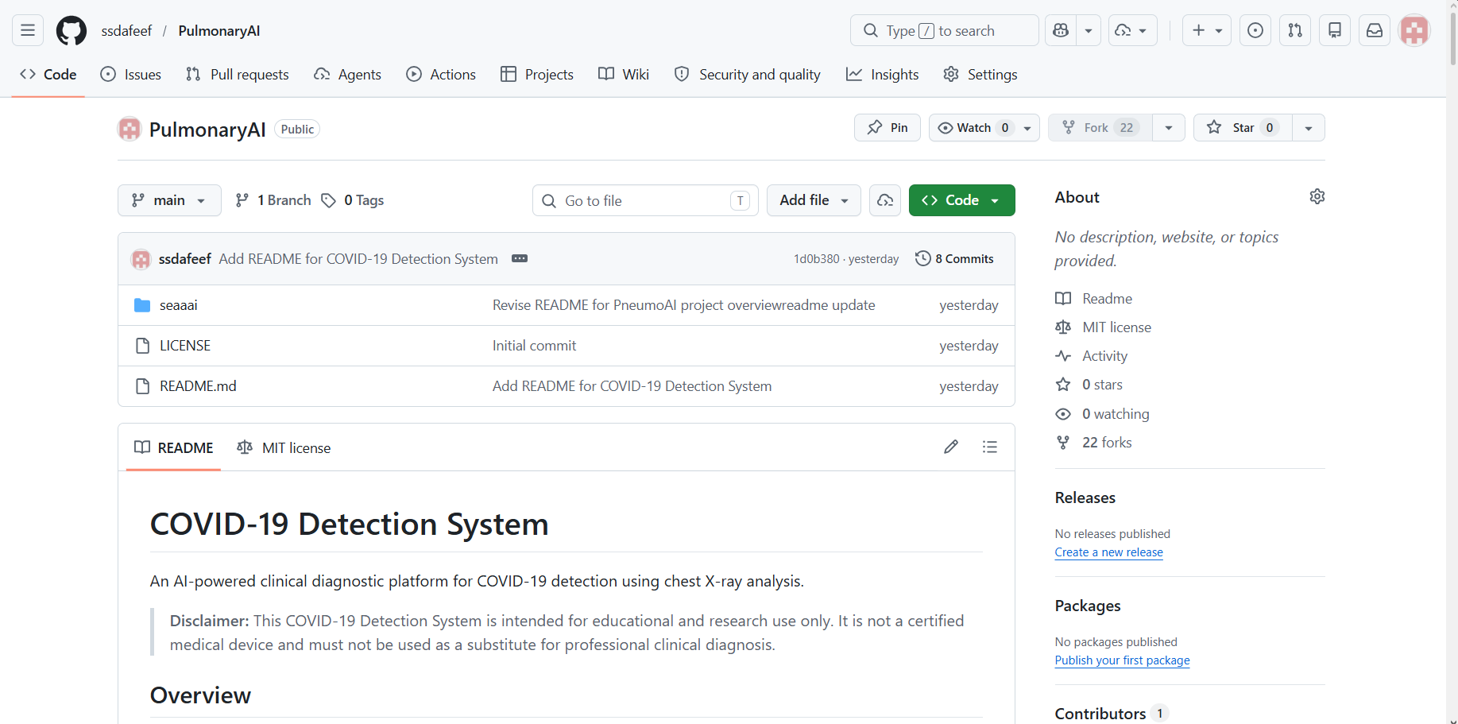

Fig 67: GitHub Repository Overview (PneumoAI Project) — https://github.com/ssdafeef/PulmonaryAI

